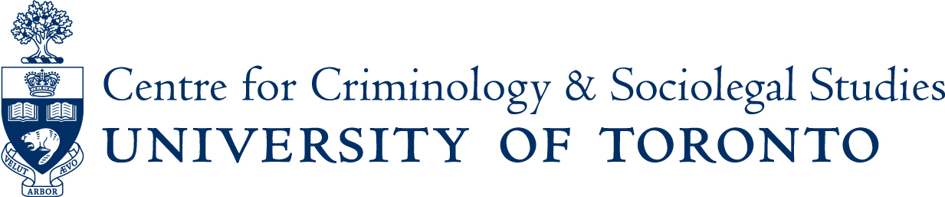

Monday November 28th, 2016 - 12:30pm-2:00pm

Mafiocracy: Organized crime and politics in Albania
Corruption and organized crime remain a challenge to new democracies such as Albania. This talk will help explain the nexus between organized crime and politics and its consequences for democracy. Dr. Zhilla’s explanation of this phenomenon is a term he coins “Mafiocracy.” Unlike what other theories propose, he believes that organized crime does not compete with state actors for power; rather, there is an alliance formed between corrupt members of the political elite and organized crime to exploit the rule of law and evade accountability. As a result, this informal agreement has allowed organized crime to access governance and dismantle law enforcement agencies.
Dr. Fabian Zhilla is a Fulbright Visiting Scholar at the Center for European Studies at Harvard University. He teaches Law and Ethics at the Canadian Institute of Technology in Albania. He is also a lead researcher at the “Study of Organized Crime” Research Unit at the Open Society Foundation (Albania) since 2014. He received his Ph.D. in Law from King’s College London in 2012 and was previously a Visiting Scholar at Georgetown University and George Washington University. His current research focuses on the interplay between organized crime and state actors in new democracies.

A light lunch and cold beverages will be provided at 12 noon.
All are welcome to attend.
Ericson Seminar Room - 2nd Floor, Canadiana Gallery Building
14 Queen’s Park Crescent West

If you are a person with a disability and require accommodation, please contact Lori Wells at416-978-3722 x226 or email lori.wells@utoronto.ca and we will do our best to make appropriate arrangements.

