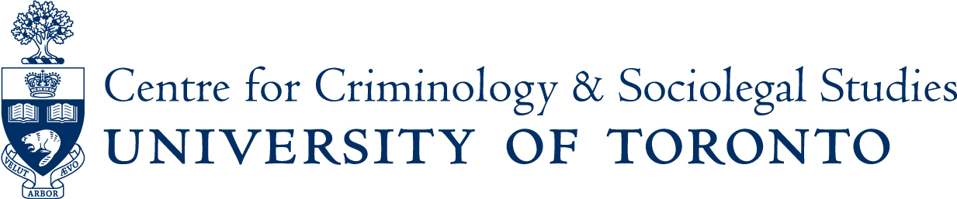

THE STATE OF URBAN ETHNOGRAPHY:

A ROUNDTABLE DISCUSSION
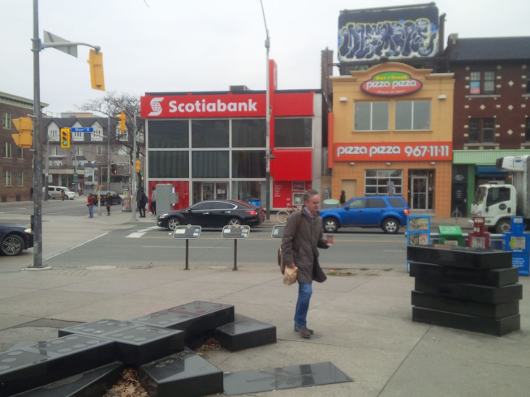

Speakers: Sandra Bucerius (University of Alberta), Randol Contreras (UTM Sociology), and Jooyoung Lee (St George Sociology)
Moderator: Bea Jauregui (Centre for Criminology & Sociolegal Studies)
Friday January 15, 2016 3:30pm to 5:30pm
Rm 160 Canadiana Gallery Building, 14 Queen’s Park Crescent West
The workshop will be followed by a reception.

If you are a person with a disability and require accommodation, please contact Lori Wells at 416-978-3722 x226 or email lori.wells@utoronto.ca and we will do our best to make appropriate arrangements.

