2162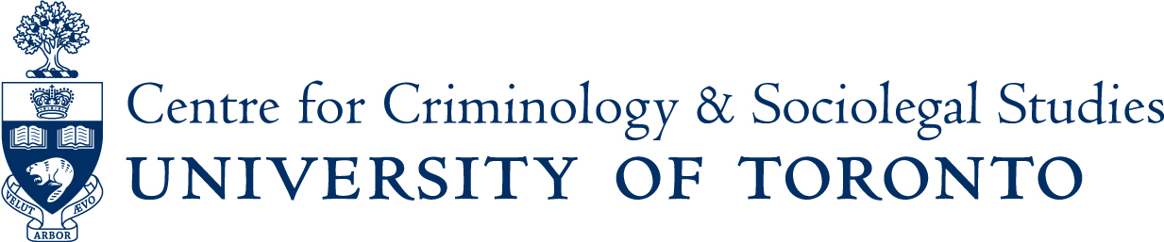
Speaker Series - Fall Term 2015

Friday, Prof. Candace Kruttschnitt will workshop the presidential
Sept 18th address she is preparing for the American Society of Criminology
3:00-4:30pm meetings later in the fall

Friday, LIVING THE PAST: THE ANGLO-CANADIAN HISTORY
Sept 25th OF CRIMINAL JUSTICE
3 to 5pm A panel discussion with Prof. Emeritus John Beattie,
Prof. Doug Hay (York University), and Prof. Jim Phillips
(U of T – Law School) Reception to follow 5-6pm

Monday, THE POLYCENTRIC GOVERNANCE OF ONLINE CRIME:
Sept 28th INTERNATIONAL POLICE COOPERATION NETWORKS
12:30-2pm Prof. Benoit Dupont, Criminology - Universite de Montreal

Wednesday, NEO-NAZI HATE CRIMES IN RUSSIA: VARIETIES,
Oct 21st CAUSES, AND INTERCONNECTIONS
12:30-2pm Prof. Richard Arnold, Muskingum Univerisity (Ohio)
Co-sponsored by the Centre for European, Russian, and Eurasian
Studies

Wednesday, LAW AT THE NEXUS OF POLITICS: HUMANITARIAN
Nov 25th SENTIMENTALITY IN THE RULE OF LAW
4 to 6pm MOVEMENT
Prof. Kamari Clarke, Global and International Studies, Carleton University
Note* - this talk, whose main sponsor is the Women/Gender
Studies Institute, will likely take place in the Jackman Humanities
Building – exact location to be confirmed

LOCATION: Unless otherwise indicated, events are held in the Ericson Seminar Room, Rm 265, Canadiana Gallery Building, 14 Queen’s Park Crescent West
ALL ARE WELCOME TO ATTEND

For talks starting at 12:30pm, a light lunch and cold beverages will be provided at 12:00pm in the Centre lounge.
If you are a person with a disability and require accommodation, please contact Lori Wells at416-978-3722 x226 or email lori.wells@utoronto.ca and we will do our best to make appropriate arrangements.

