**Kelly Hannah-Moffat** is Vice President HR & Equity and [Director of the Centre of Criminology and Sociolegal Studies](http://www.criminology.utoronto.ca/).

Professor Hannah-Moffat has made important contributions to criminology, sociology and legal issues. Her interdisciplinary research on risk, punishment, and marginalized and diverse populations has contributed to the advancement of knowledge in sociology, criminology, law and social justice, and penal history.

She has published numerous articles and books on risk theory, punishment, penal change, gender and diversity, procedural fairness in specialized courts and criminal justice decision-making. Her research has traced the historical and conceptual antecedents of gender based punishment, the unintended outcomes of liberal and formal rights based penal reform agendas, international conventions and minimum rights standards, and the structural challenges to prisoners’ ability to exercise human rights while in custody.

Professor Hannah-Moffat’s recent work critiques penal practices such as long-term segregation, inadequate access to mental health services, isolation, violations of international conventions and minimum standards, and indicates structural challenges to prisoners’ ability to exercise human rights while in custody. She reveals that some outcomes of rights-based advocacy, such as the ideal of ‘gender–responsive’ punishment, are themselves problematic, and instead proposes improved human rights and access to trauma informed programming, mental health care and more cross-institutional, community-based initiatives.

Professor Hannah-Moffat is currently involved in two civil liberties cases, one going to BC courts in January. She was also an expert witness in Ashley Smith case.

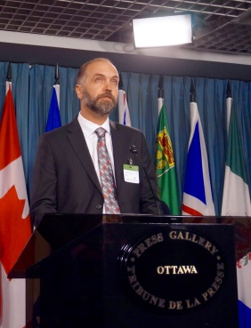**Andrew Brouwer** is Senior Counsel in Refugee Law at Legal Aid Ontario.

Working out of the Refugee Law Office, he leads LAO’s law reform and test case strategy to improve access to justice in the area of refugee and immigration law, including immigration detention, and provides strategic and policy advice to LAO management. Mr. Brouwer is recognized by the Law Society of Upper Canada as a Certified Specialist in Citizenship and Immigration Law. He appears before all levels of court and tribunal, including all divisions of the Immigration and Refugee Board, the Federal Court, Federal Court of Appeal, and the Supreme Court of Canada. He also represents clients before the United Nations Committee Against Torture and the United Nations Human Rights Committee. Mr. Brouwer co-chairs the Advocacy Committee of the Canadian Association of Refugee Lawyers and serves on the legal advisory committees of the Canadian Council for Refugees and the Canadian Centre for Victims of Torture. He has been working closely with the Faculty of Law's International Human Rights Program in their projects on immigration detention.

**Insiya Essajee** has been counsel to the Ontario Human Rights Commission since 2012. She has a B.Arts Sc. (2007) from McMaster University and a J.D. (2011) from the University of Toronto. While at the Commission, she has been involved in litigation, government submissions, and policy support aimed towards addressing systemic discrimination in Ontario. She is the lead on the Commission’s work relating to prison issues, particularly relating to the use of segregation and gender discrimination in Ontario’s correctional system. Ms. Essajee has represented the Commission in cases before the Human Rights Tribunal of Ontario, Ontario Superior Court of Justice, and Court of Appeal for Ontario.