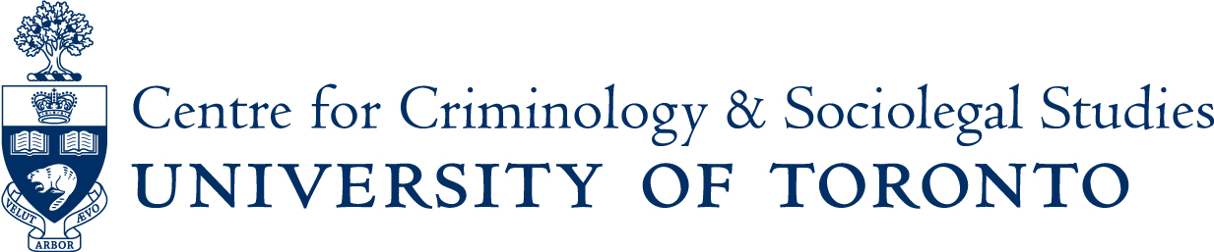

Roundtable discussion:

Criminal Justice History

Speakers: Prof. Li Chen (Historical & Cultural Studies, University of Toronto),
Prof. Paul Craven (Social Science, York University) and
Prof. Jim Phillips (Faculty of Law, University of Toronto)
Moderator: Prof. Doug Hay (Osgoode & History Dept., York University)

Friday March 6th, 2015
3:00pm to 5:00pm

Ericson Seminar Room
2nd Floor, Canadiana Gallery Building
14 Queen’s Park Crescent West
The discussion will be followed by a wine and cheese in the Centre’s lounge from 5:00pm-6:00pm
If you are a person with a disability and require accommodation, please contact Lori Wells at 416-978-3722 x226 or email lori.wells@utoronto.ca and we will do our best to make appropriate arrangements.

