The Compassionate Justice Speaker Series
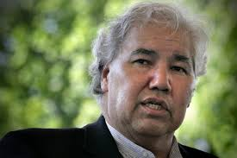
Justice Murray Sinclair
Speaking on the recommendations set out in his report from the Truth and Reconciliation Commission
Sunday, November 15, 2015 12:30 pm
Eglinton St. George’s United Church
35 Lytton Blvd. Toronto Ontario

- Free Admission Donations welcomed
- Light lunch served at 11:45
- For more information, call Jim Black 416-782-7478

