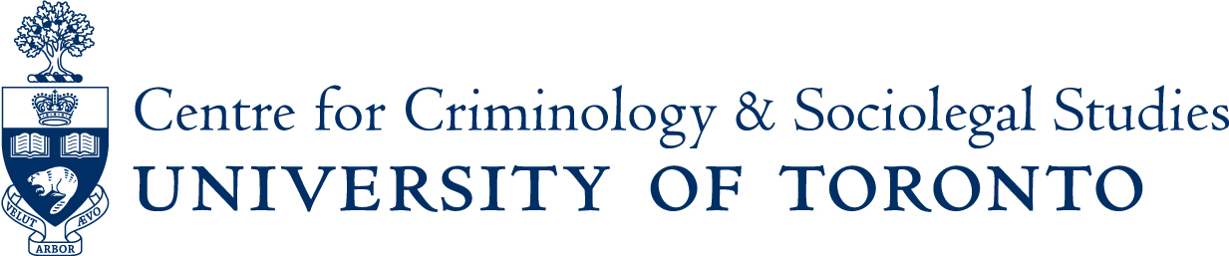

Roundtable Discussion
Thursday January 26th
12:30pm to 2:00pm

“The Trump-Russia Nexus: the Evidence, the Significance, and the Consequences?”

A panel discussion with
Prof. Matthew Light, Prof. Peter Solomon & Prof. Leon Kosals

Centre for Criminology & Sociolegal Studies, University of Toronto
Ericson Seminar Room
2nd Floor, Canadiana Gallery Building
14 Queen’s Park Crescent West

A light lunch & cold beverages will be provided at 12:00pm in the Centre lounge
ALL ARE WELCOME TO ATTEND

If you are a person with a disability and require accommodation, please contact Lori Wells at 416-978-3722 x226 or email lori.wells@utoronto.ca and we will do our best to make appropriate arrangements.

