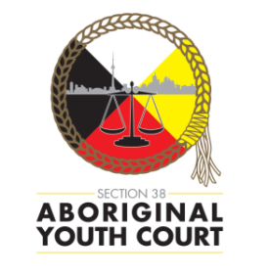**311 YOUTH/FAMILY LAW OPEN BAR SERIES presents**

**311 INDIGENOUS**

**CALLS TO ACTION: Applying *Gladue* in Youth and Child Protection Cases**

**Chair: Justice Marion Cohen**

**Panelists: Sarah Clarke,** Clarke Child and Family Law.

**Sarah Dover,** defence counsel, Brantford Indigenous Peoples Court.

**Professor Hadley Friedland,** specialist in Indigenous laws, legal methodologies in criminal justice, family and child welfare.

**Where: 311 Jarvis Street Courthouse**

**When: Monday, March 6, 2017**

**From: 4:45 p.m. to 7:00 p.m.**

**Indigenous youth criminal and child protection cases challenge us to respond to the Truth and Reconciliation Commission Calls to Action in the quest for a justice system which respects the unique circumstances of Indigenous peoples. This session will prompt you to refresh and rethink the application of *Gladue* principles, and to learn about Indigenous legal methodologies, in the youth justice and child protection contexts.**

A video download, DVD, and materials of this session will be available at [*www.research.legalaid.on.ca/login.html*](https://www.research.legalaid.on.ca/login.html). You will need your LAO solicitor number to log on to the LAO LAW website.

Refreshments will be served.

Sponsors:  Family Lawyers Association/ 311 Operations Committee

Cost of Admission for Lawyers only: $25.00. This is a continuing education program. Lawyers, Law Students and Youth and Child Protection Workers welcome. Please bring your professional identification as it may be requested prior to admittance.

If you have a personal accessibility requirement, please send an e-mail to: [Elise.Cattani@ontario.ca](mailto:Elise.Cattani@ontario.ca) with the subject line “Accessibility Requirement”. You will be contacted by one of our team members to better understand how we can meet your needs to make this a positive learning experience.