Olivieri Lectureship on
Medical Ethics
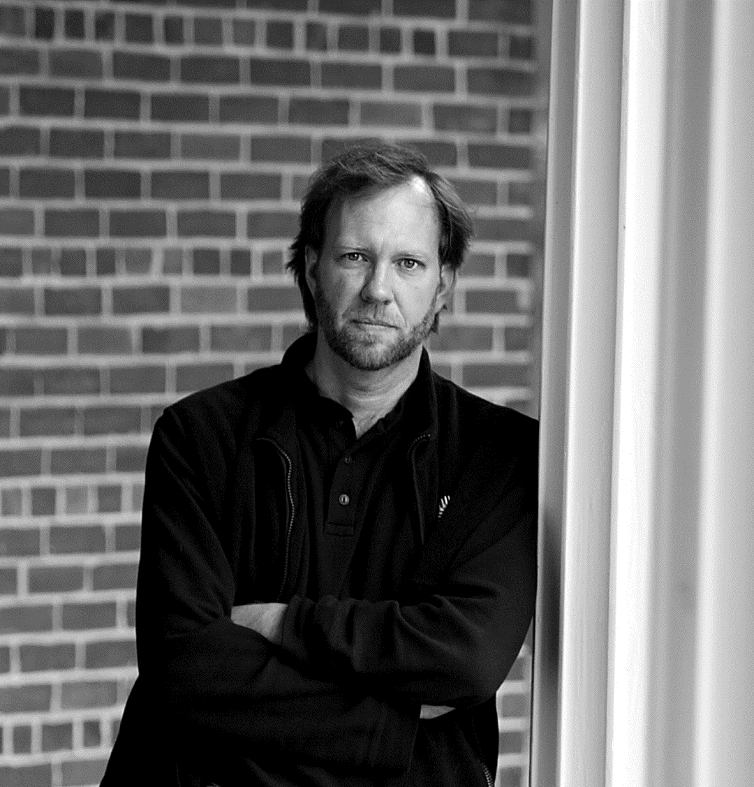
Carl Elliott MD PHD
Professor, Center for Bioethics and the Department of Pediatrics.
Affiliate faculty member, Department of Philosophy and the School of Journalism and Mass Communications, University of Minnesota.
Author of White Coat, Black Hat: Adventures on the Dark Side of Medicine and Better than Well: American Medicine Meets the American Dream.

Thursday, November 14, 4pm

Bahen Centre, 40 St George St, Room BA1130
University of Toronto, St. George Campus
Reception to follow

